Ex. No. 7 | WORKING WITH JQUERY
Date of Exercise | 11.09.2026
GitHub Host Link | https://gautham75.github.io/Web-Technology-Lab/

Aim
To create a website using JQuery actions.
Description
jQuery is a fast, small, and feature-rich JavaScript library. It makes things like HTML document traversal and manipulation, event handling, animation, and Ajax much simpler with an easy-to-use API that works across a multitude of browsers. With a combination of versatility and extensibility, jQuery has changed the way that millions of people write JavaScript.

The basic syntax of jQuery is as follows:
$(document).ready(function(){
$(&quot;p&quot;).click(function(){
$(this).hide();
});
});
Sample JQuery Code
<!DOCTYPE html>
<html lang="en">
<head>
<meta name="viewport" content="width=device-width, initial-scale=1.0">
<script
src="https://ajax.googleapis.com/ajax/libs/jquery/3.6.0/jquery.min.js">
</script>

<script>
$(document).ready(function(){
$('#btn').click(function(){
let num1 = parseInt($('#t1').val());
let num2 = parseInt($('#t2').val())
let sum = num1 + num2;
$('#result').val(sum);
$('#box').html("Result: " + sum);
})
})
</script>
</head>
<body>
Number1: <input type="text" id="t1"><br><br>
Number2: <input type="text" id="t2"><br><br>
<button id="btn">Addition</button><br><br>
Result: <input type="text" id="result" readonly><br><br>
<div id="box" style="background-color:blue;color:white;width:300px;">
</div>
</body>
</html>
Sample questions
1) Create a web application to develop the following Budget Calculator using HTML, CSS, and JQuery as given below. Here, the room rent, accessories, emergency and saving get as percentage (%), then divide the given amount based on the percentage and display each value in the place provided when the "Evaluate My Money" button. If the amount is not able to divide by the given percentage values, then show an alert message.
Program
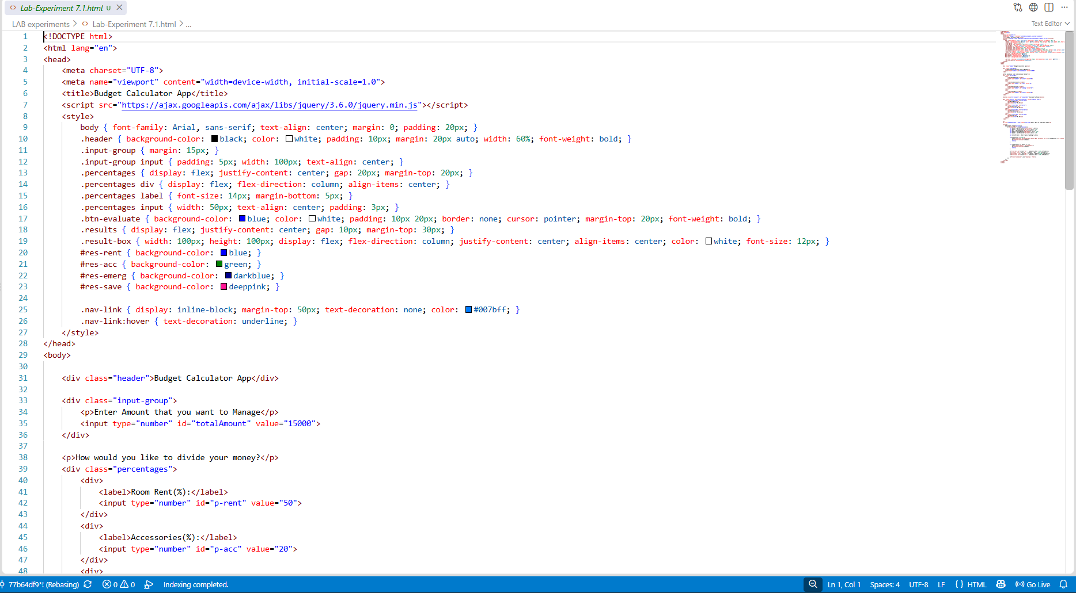
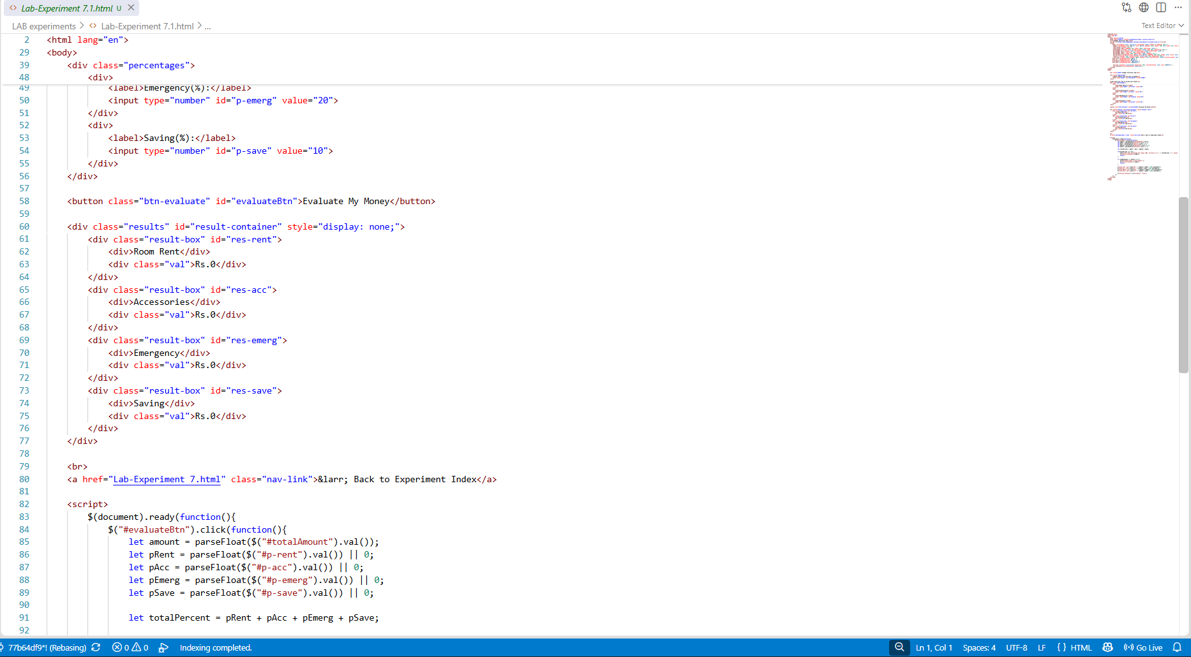
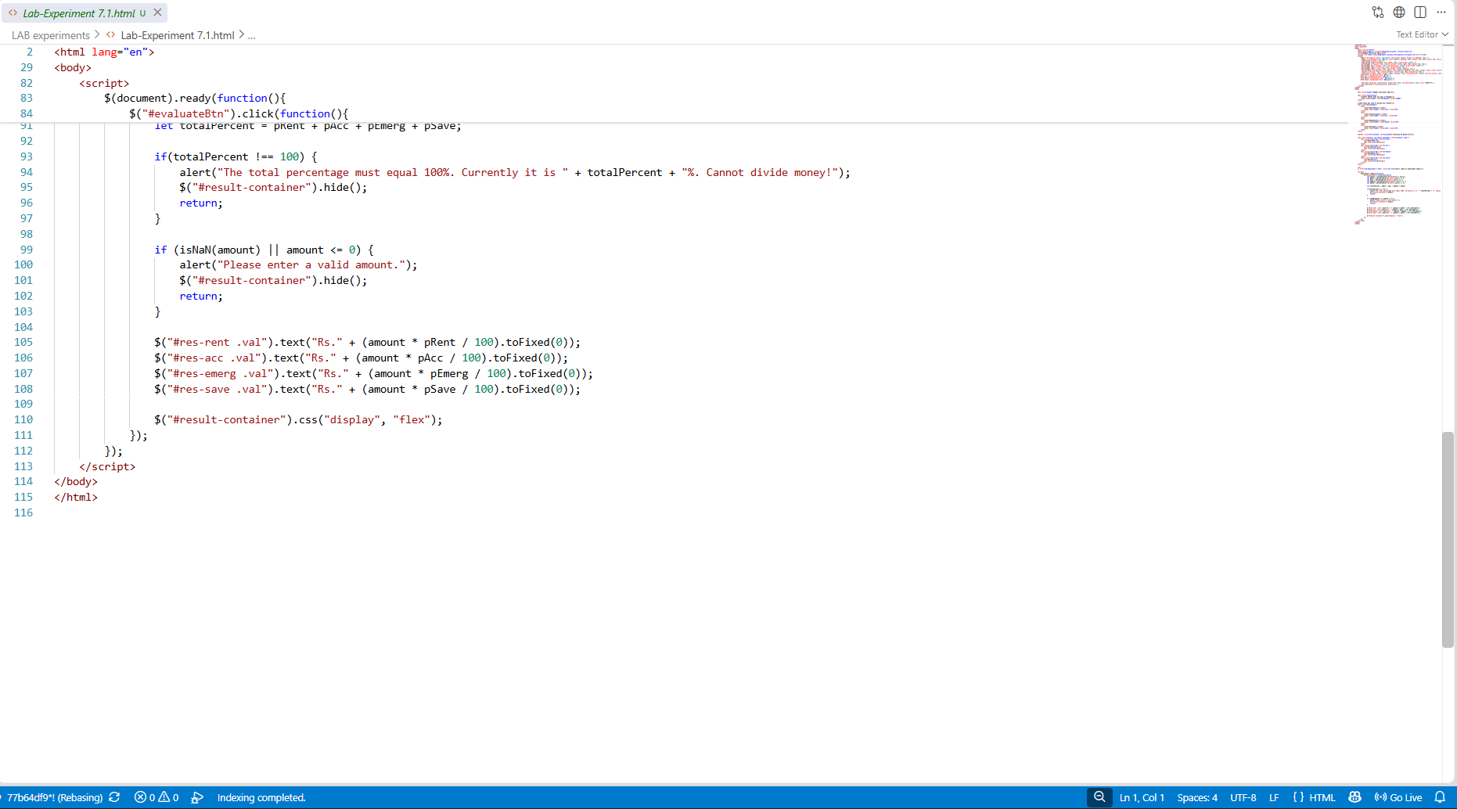
Output
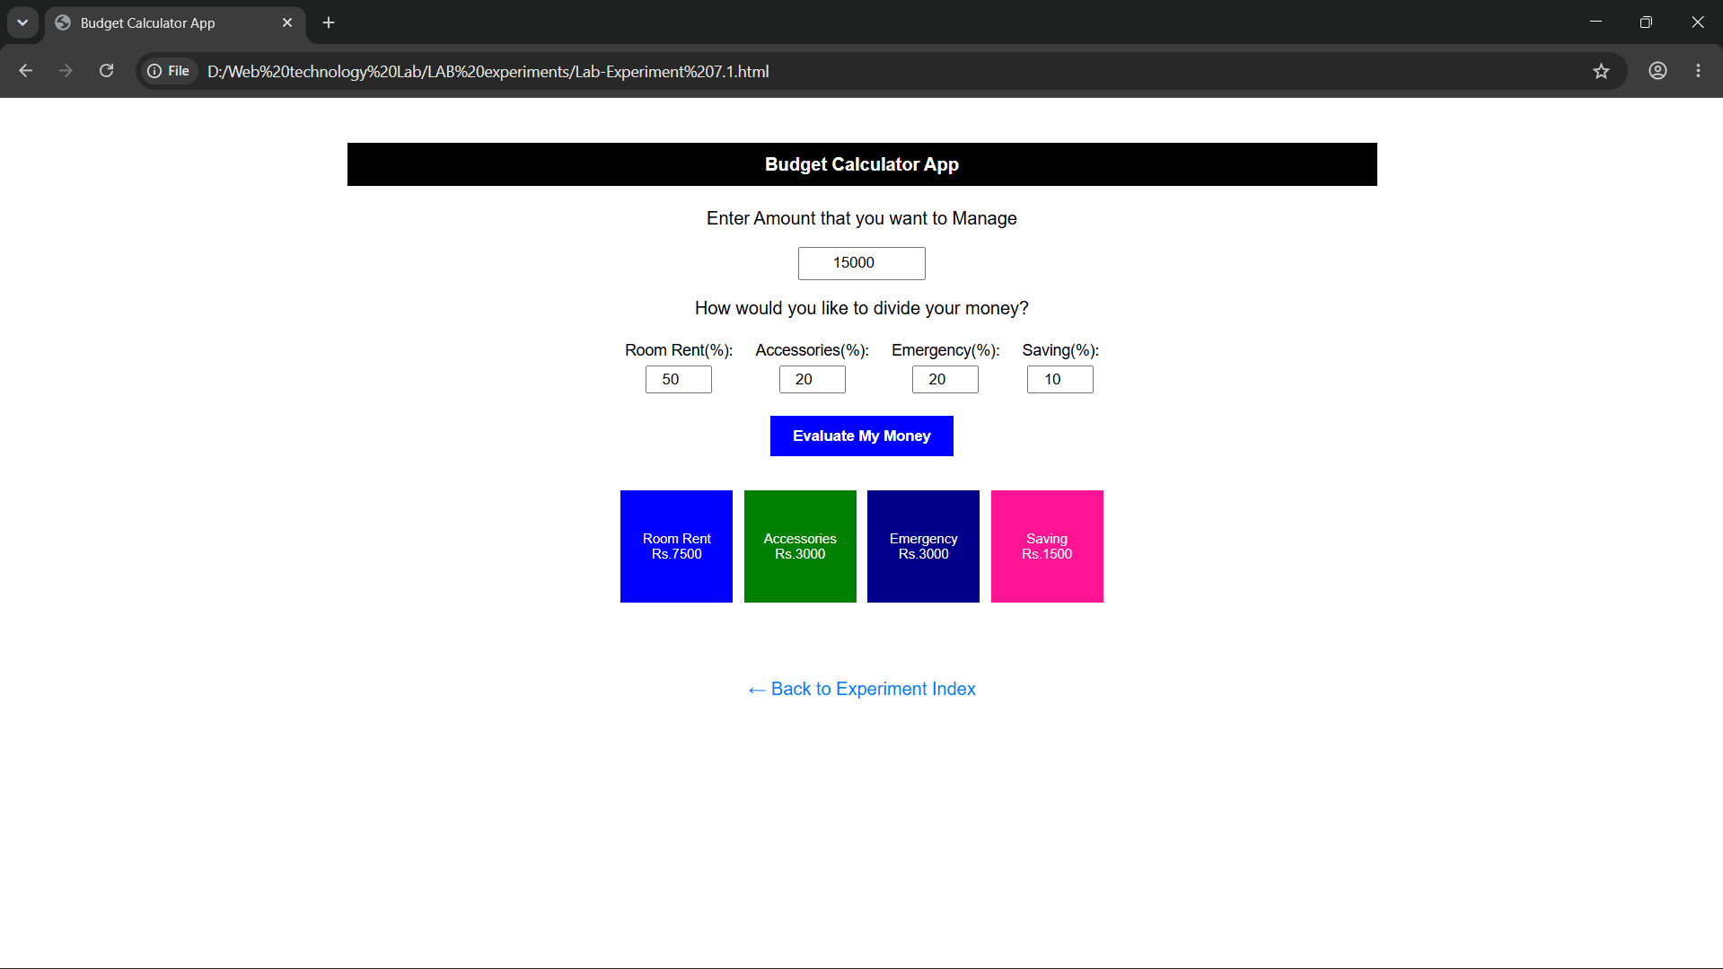
2) Design a webpage using HTML, CSS and JQuery as per the following design and perform the Cake order calculation using JQuery actions.

Program
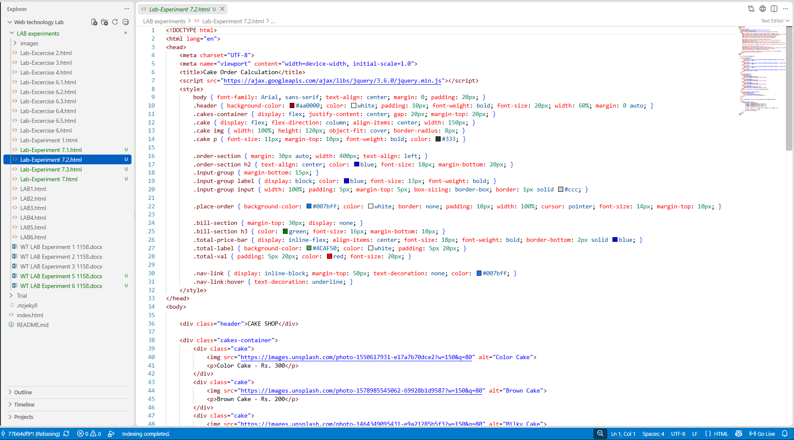
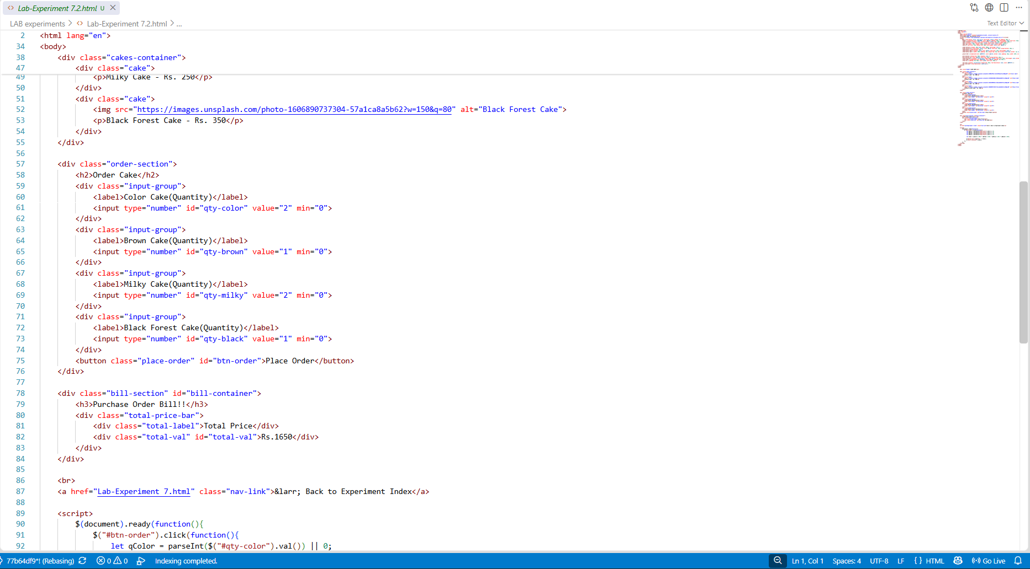
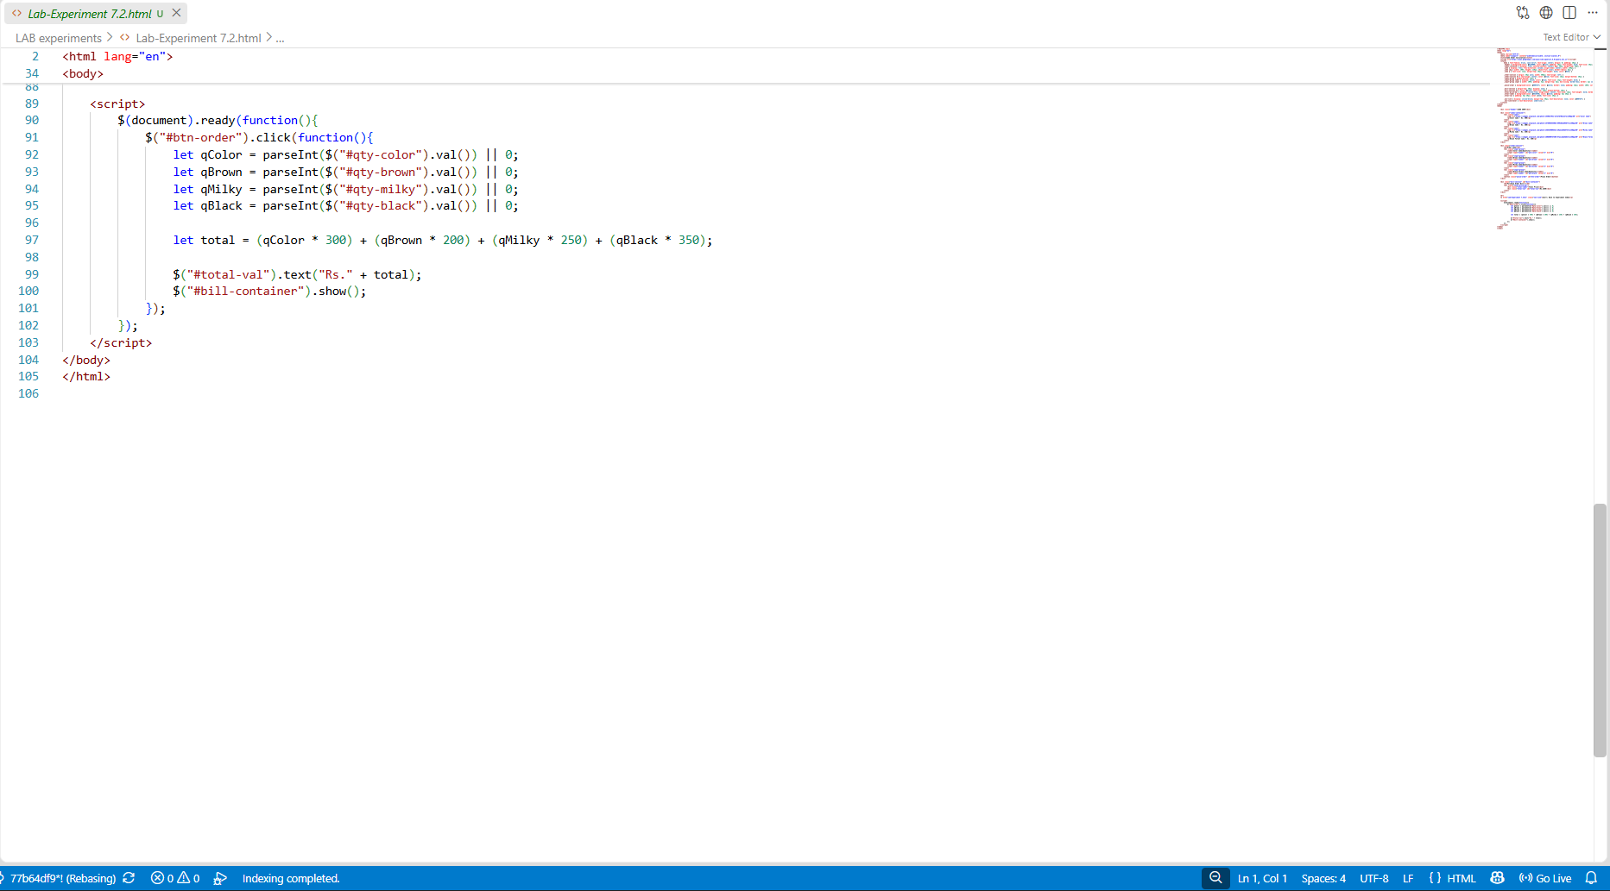

Output
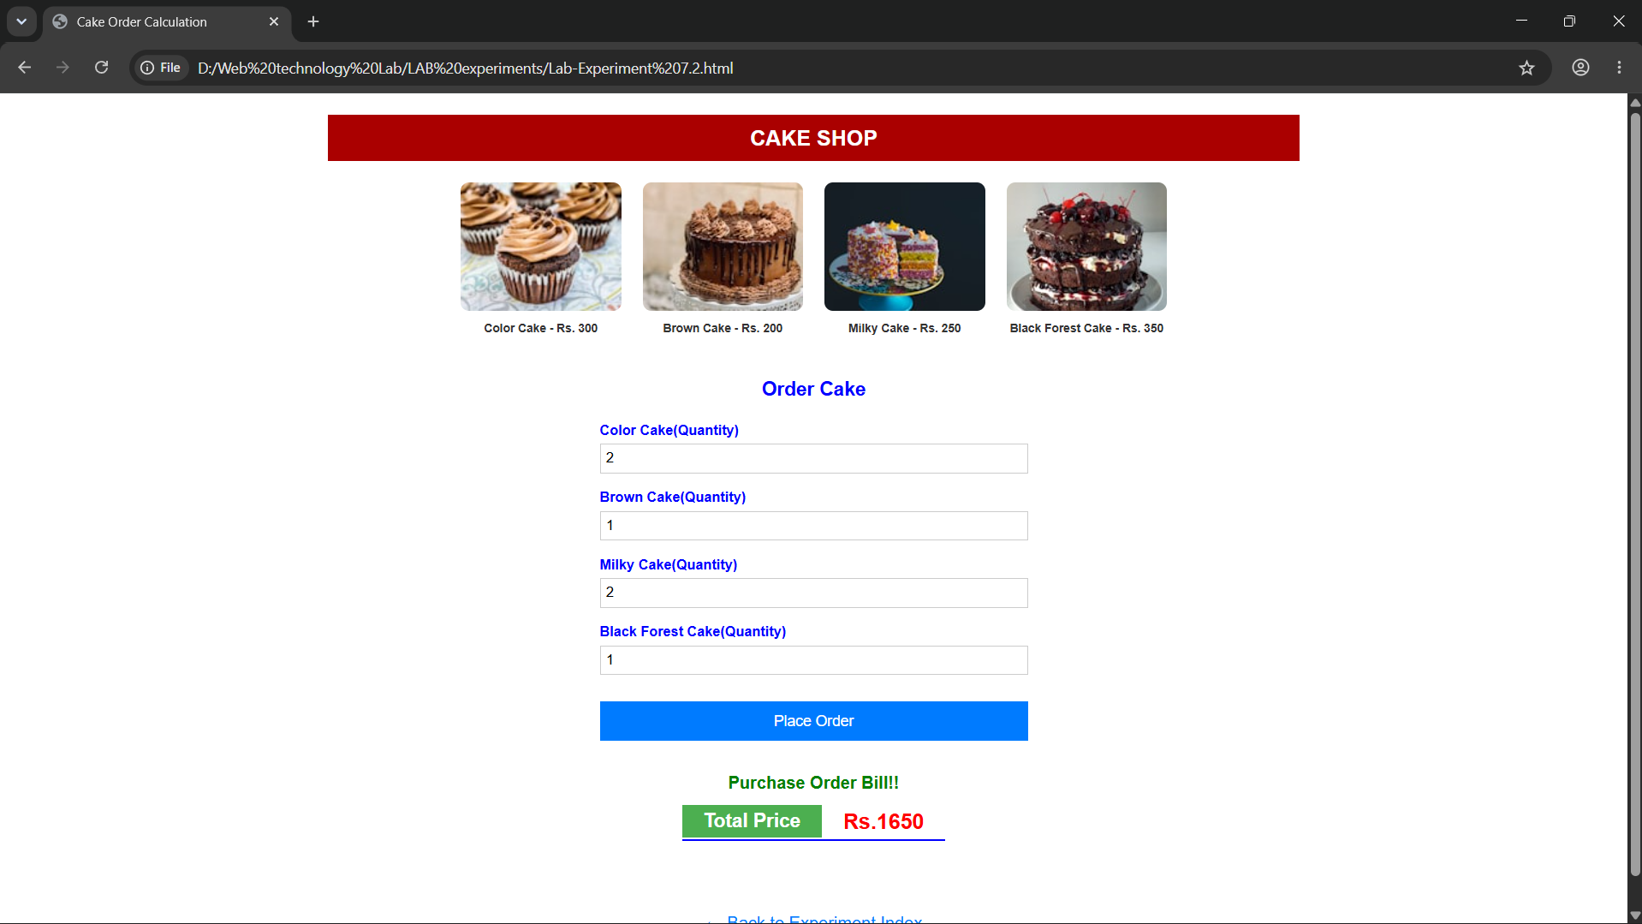

3) Create a car body workshop using JQuery where in you should be able to change the color of the car, glass tint, size of the tyres.

Program
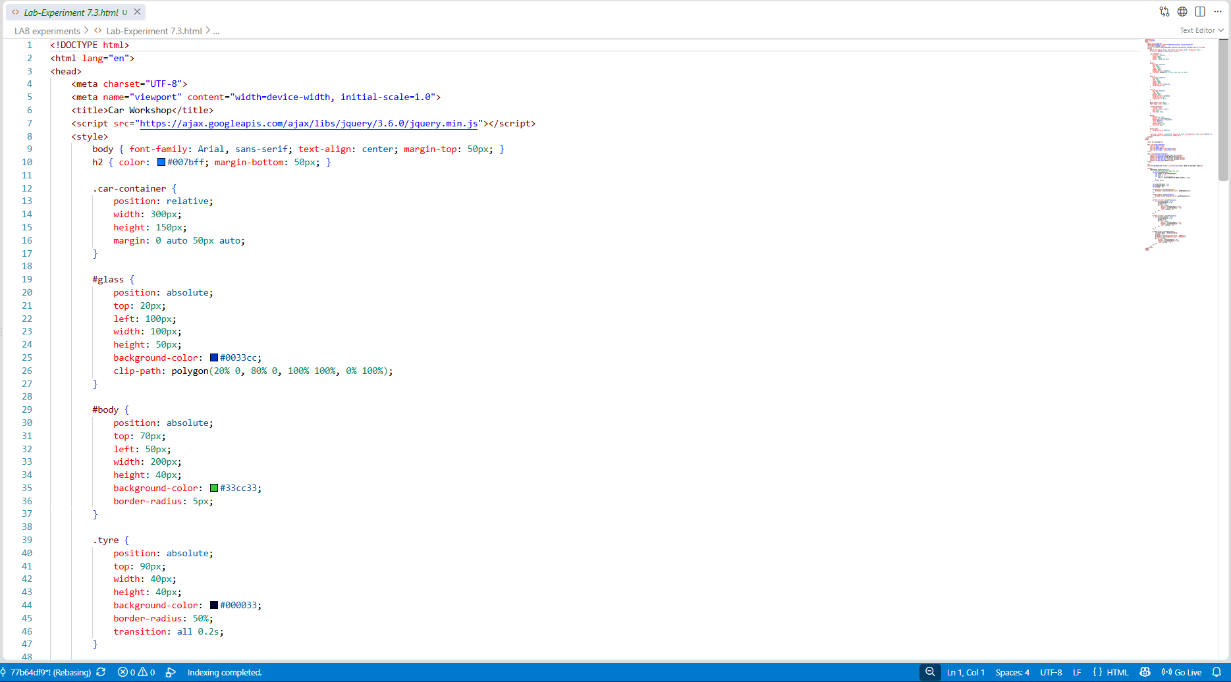
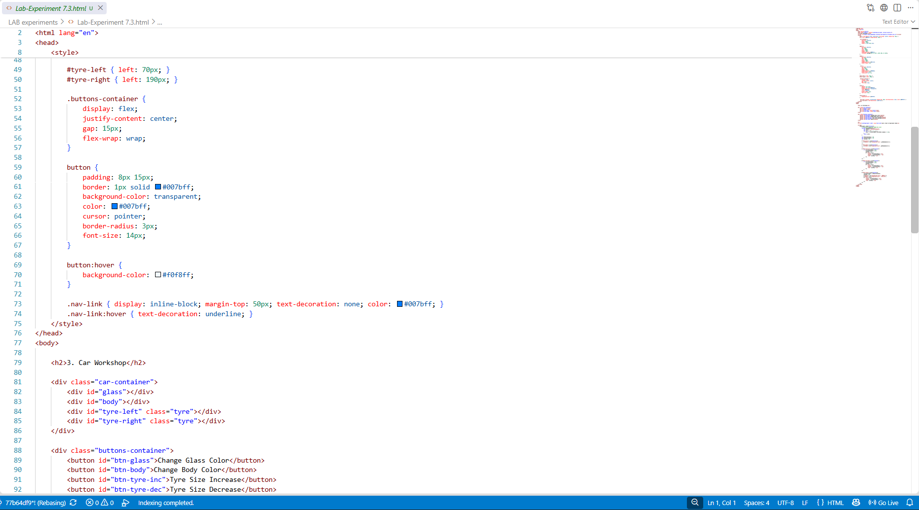
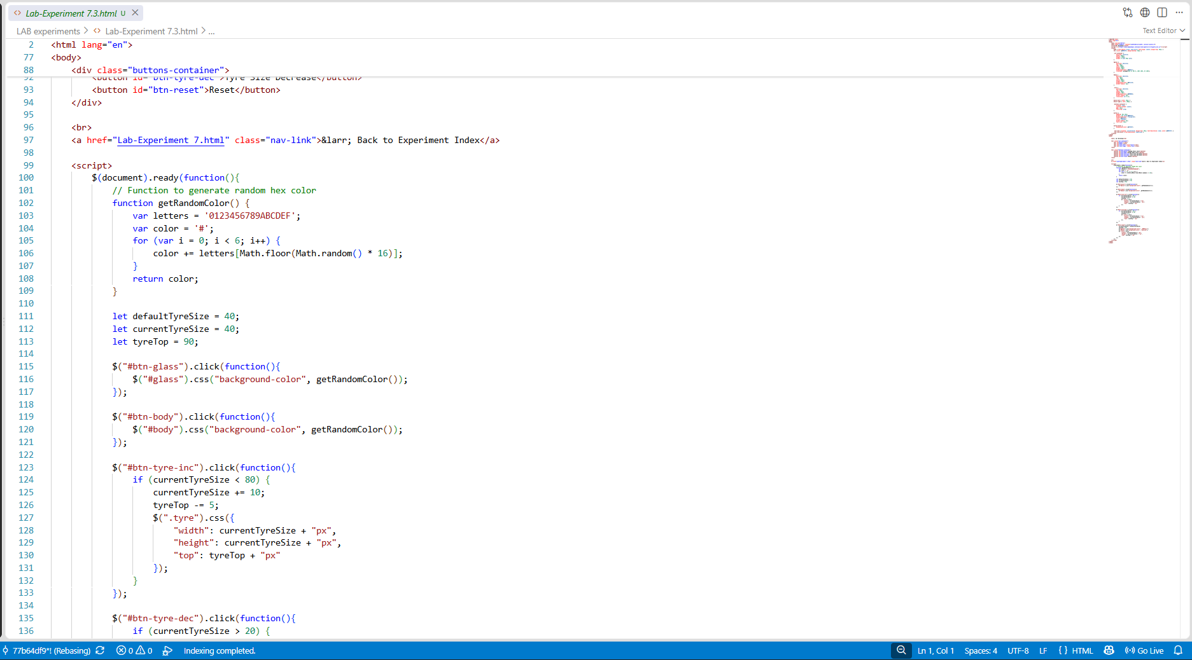

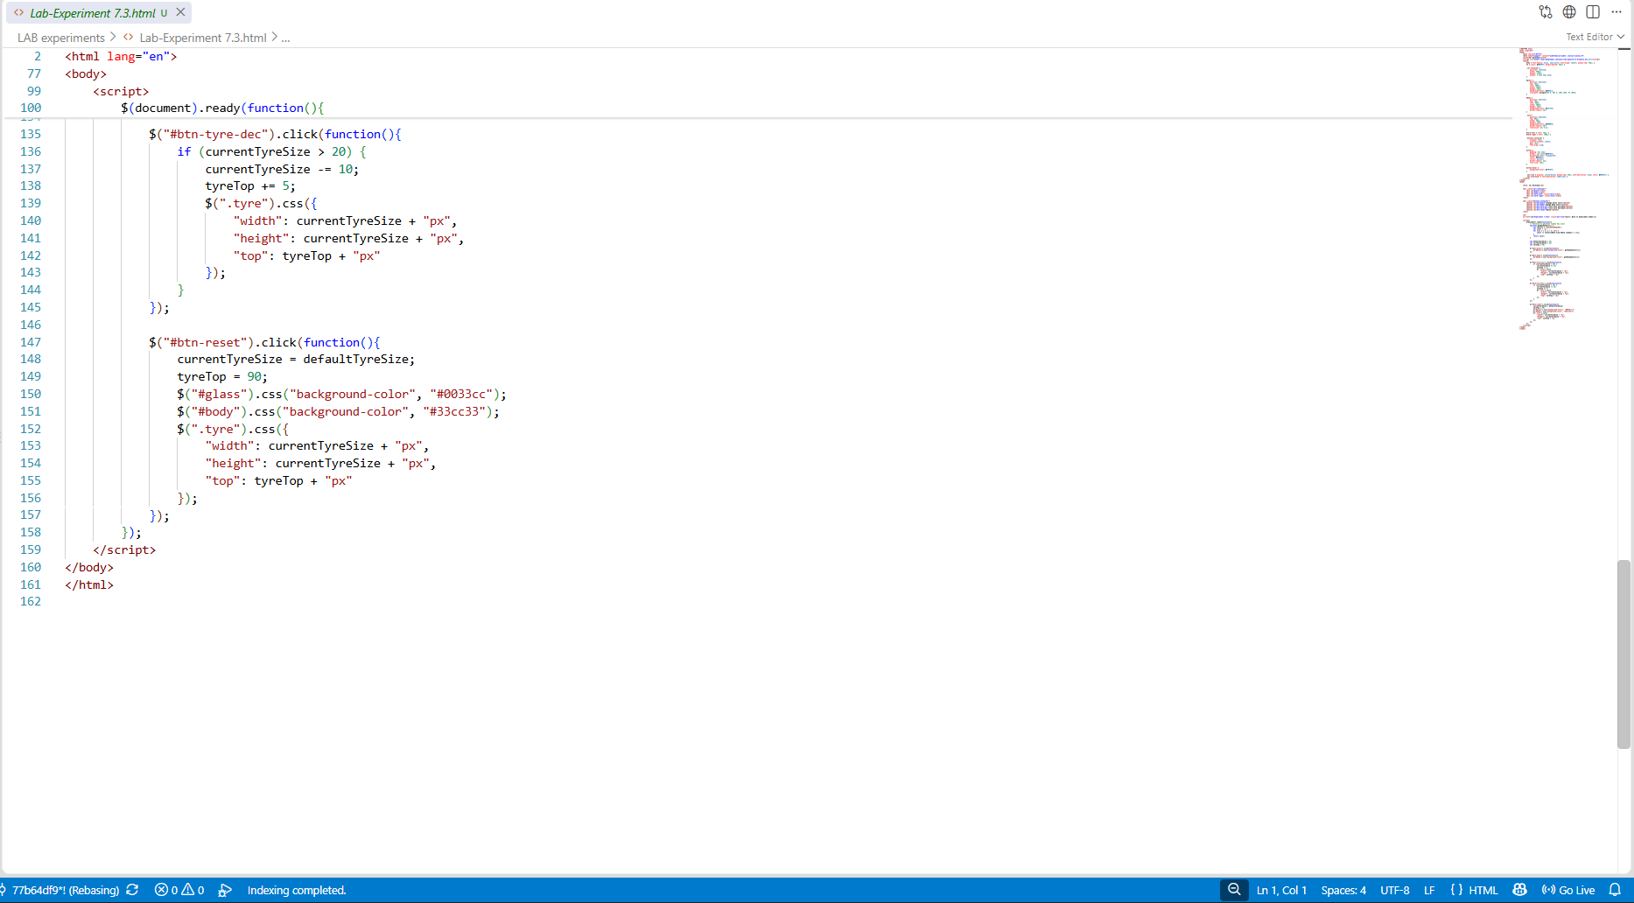
Output
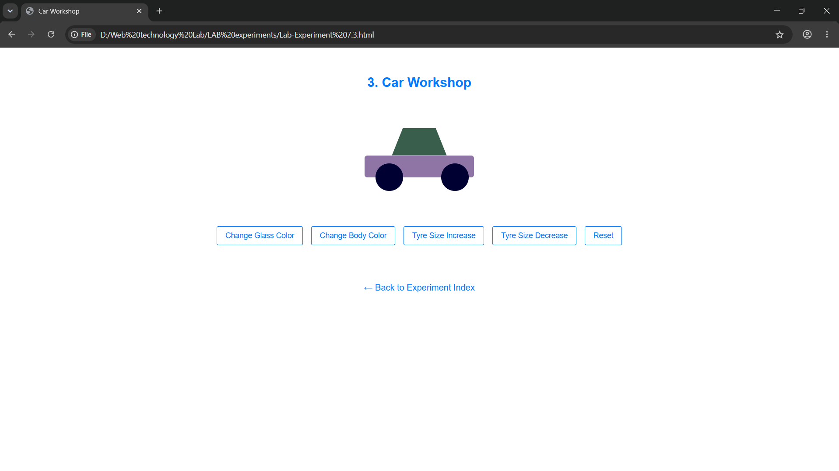
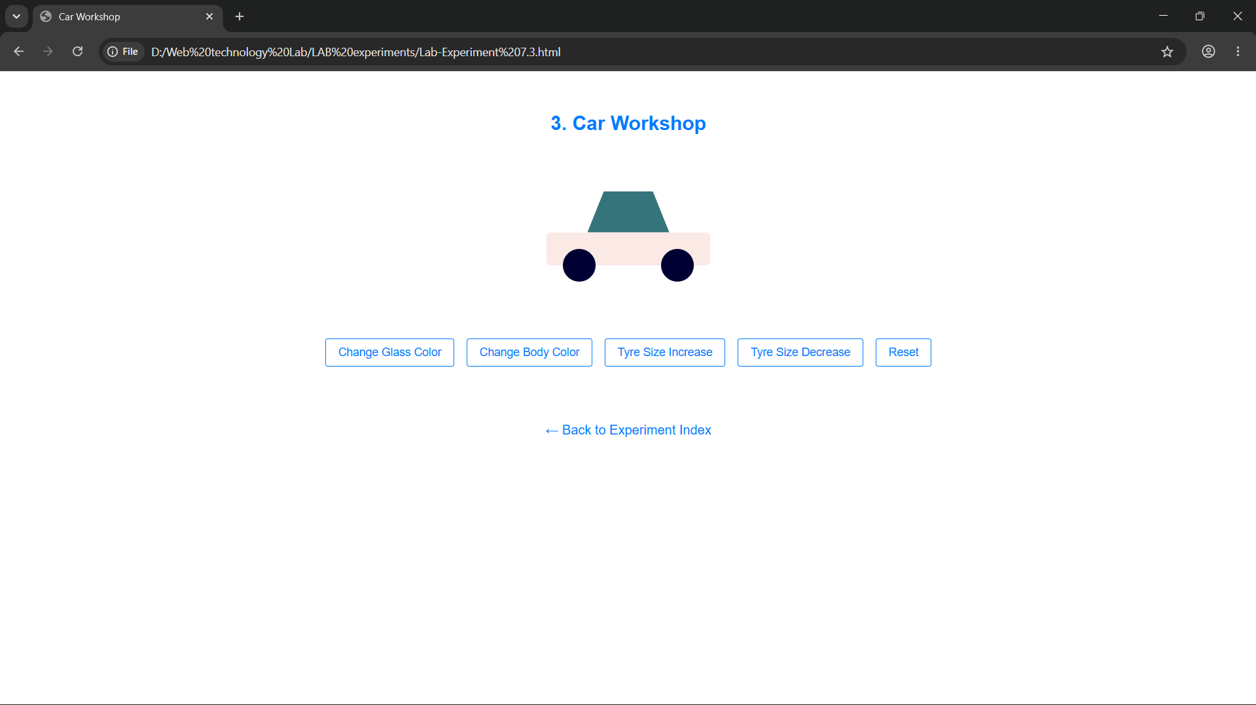

Result
Thus, all three jQuery programs were successfully implemented and executed, demonstrating various jQuery operations such as effects, calculations, DOM manipulation, employee management, and element traversing.

